Question 1a:
Consider the following queries on relations R(A,B) and S(B,C):
- Query 1: SELECT * FROM R, S WHERE R.B = S.B AND R.A = 5
- Query 2: SELECT * FROM R, S WHERE R.B = S.B AND R.A = 5 AND S.C = 10
The following two plans are being considered:
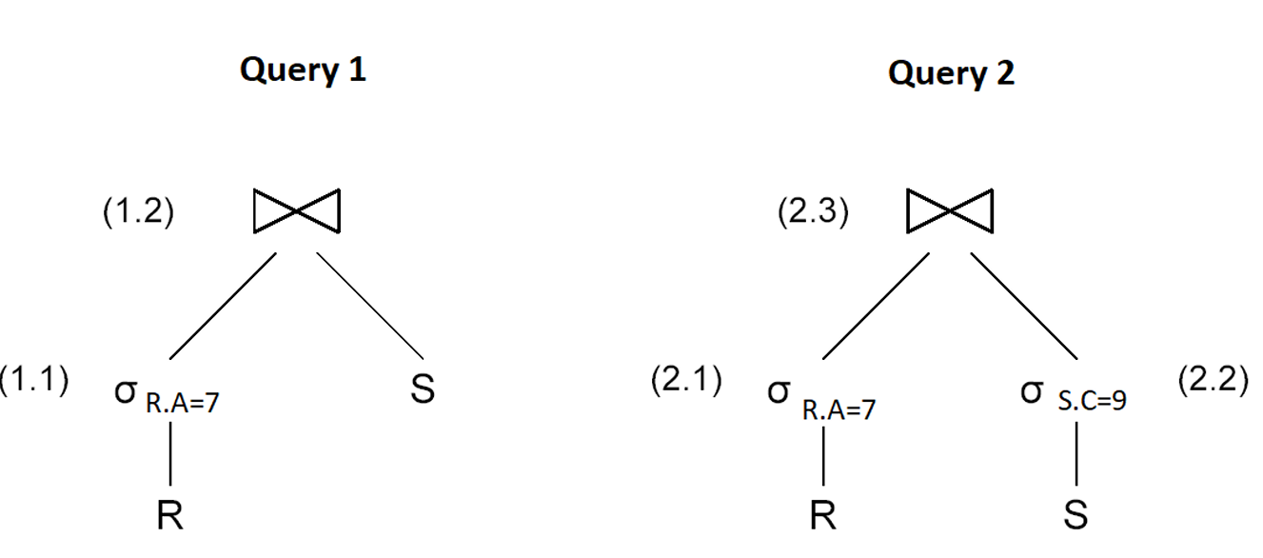

Query 1 Query 2
(1.2) (2.3)
(1.1) (2.1) (2.2)
R.A=5 S R.A=5 S.C=10
R R S
Relation R has 50,000 tuples with 20 tuples per disk block, V(R,A)=5, and V(R,B)=10. Similarly, S has 25,000 tuples with 25 tuples per disk block, V(S,B)=4, and V(S,C)=15. Assume values are distributed over possible V(Relation,Attribute) values (not over possible domain values).
In this exercise, we make the following additional assumptions:
- The join is implemented as a hash-join;
- The intermediate result produced by operation (1.1) is not written to disk;
- Hash buckets are stored on disk;
- The final result is kept in main-memory;
- There is enough memory to execute the hash join algorithm.
a) How many disk I/O’s does Query 1 require?
b) Also assume that the result of neither (2.1) nor (2.2) is stored to disk. How many disk I/O’s does Query 2 require?

Question 1b:
Consider the following queries on relations R(A,B) and S(B,C):
- Query 1: SELECT * FROM R, S WHERE R.B = S.B AND R.A = 3
- Query 2: SELECT * FROM R, S WHERE R.B = S.B AND R.A = 3 AND S.C = 7
The following two plans are being considered:
Query 1 Query 2
(1.2) (2.3)
(1.1) (2.1) (2.2)
R.A=3 S R.A=3 S.C=7
R R S
Relation R has 40,000 tuples with 15 tuples per disk block, V(R,A)=4, and V(R,B)=8. Similarly, SS has 20,000 tuples with 20 tuples per disk block, V(S,B)=3, and V(S,C)=10. Assume values are distributed over possible V(Relation,Attribute) values (not over possible domain values).
In this exercise, we make the following additional assumptions:
- The join is implemented as a hash-join;
- The intermediate result produced by operation (1.1) is not written to disk;
- Hash buckets are stored on disk;
- The final result is kept in main-memory;
- There is enough memory to execute the hash join algorithm.
a) How many disk I/O’s does Query 1 require?
b) Also assume that the result of neither (2.1) nor (2.2) is stored to disk. How many disk I/O’s does Query 2 require?

Question 1c:
Consider the following queries on relations R(A,B) and S(B,C):
- Query 1: SELECT * FROM R, S WHERE R.B = S.B AND R.A = 9
- Query 2: SELECT * FROM R, S WHERE R.B = S.B AND R.A = 9 AND S.C = 12
The following two plans are being considered:

Query 1 Query 2
(1.2) (2.3)
(1.1) (2.1) (2.2)
R.A=9 R.A=9 S.C=12
R R S
Relation RR has 70,000 tuples with 25 tuples per disk block, V(R,A)=7, and V(R,B)=14. Similarly, SS has 35,000 tuples with 35 tuples per disk block, V(S,B)=6, and V(S,C)=25. Assume values are distributed over possible V(Relation,Attribute) values (not over possible domain values).
In this exercise, we make the following additional assumptions:
- The join is implemented as a hash-join;
- The intermediate result produced by operation (1.1) is not written to disk;
- Hash buckets are stored on disk;
- The final result is kept in main-memory;
- There is enough memory to execute the hash join algorithm.
a) How many disk I/O’s does Query 1 require?
b) Also assume that the result of neither (2.1) nor (2.2) is stored to disk. How many disk I/O’s does Query 2 require?

Key Features of These Questions:
- Query Plans:
  - Each query involves a join between two relations RR and SS, with additional filtering conditions.
- Relation Statistics:
  - Each relation has a specified number of tuples, tuples per block, and distinct values for attributes.
- Assumptions:
  - The join is implemented as a hash-join.
  - Intermediate results are not written to disk.
  - Hash buckets are stored on disk.
  - The final result is kept in main-memory.
- Disk I/O Calculations:
  - The goal is to compute the number of disk I/O’s required for each query under the given assumptions.

2a) Suppose B(R) = 30000, B(S) = 70000, and the number of main memory blocks is M = 150. We want to perform the natural join of R and S using a hash join algorithm.
a) How many partitions are needed to ensure that each partition of R fits in memory?
b) Describe the process of building and probing the hash table and compute the number of I/O operations required.
c) How many main memory blocks would be required to perform a one-pass hash join?

2b) Suppose B(R) = 10000, B(S) = 25000, and we have M = 200 main memory blocks available. We wish to join R and S using a sort-merge join algorithm, assuming both relations are initially unsorted.
a) How many sorting passes are required for each relation?
b) Describe how the sorted relations are merged and the number of I/O’s required.
c) What is the minimum number of main memory blocks needed for an efficient sort-merge join?

2c) Suppose B(R) = 15000, B(S) = 40000, and the available main memory blocks are M = 120. We want to perform a nested-loop join of R and S.
a) How many block accesses are required for a tuple nested-loop join?
b) How many block accesses are required for a block nested-loop join?
c) What is the minimum number of memory blocks needed to perform a single-pass block nested-loop join?

Example 1: External Merge Sort for Join Preparation
Suppose we have two relations, R and S, with the following properties: B(R)=15000B, B(S)=40000, The number of available main memory blocks is M=80.
- Both relations are clustered but unsorted, and we want to sort them before applying a merge join.
Questions:
a) How many passes do we need to sort R and S separately using external merge sort?
b) Describe the execution of the merge join and calculate the I/O cost.
c) How many main memory blocks would be needed to perform a one-pass join?

Example 2: Sort-Merge Join with Different Memory Constraints
Consider two relations:
- B(R)=30000, B(S)=70000, and M = 120.
- Both relations are not sorted and must be sorted before using a merge join.
- Assume R and S are clustered on disk.
Questions:
a) Compute the number of passes needed to sort R and S using external merge sort.
b) How many total I/O operations are required for the full sort-merge join process?
c) If we increase the available memory to M=250M = 250M=250, how would this affect the sorting and join efficiency?

Example 3: Comparing Sort-Merge and Block Nested Loop Joins
We have two relations: B(R)=50000 and B(S)=90000, The number of main memory blocks available is M=60.
- The relations are not sorted, and we want to perform a join.
Questions:
a) How many passes are required if we first sort both relations and use a merge join?
b) Compare the total I/O cost of using a sort-merge join versus a block nested loop join under these constraints.
c) What is the minimum number of memory blocks needed for a one-pass join, and is it feasible in this case?

Question 1: Sort-Merge Join with Clustered Relations
Suppose B(R)=15000, B(S)=30000, and the number of main memory blocks is M=201. We want to perform the natural join of R and S using a sort-merge join algorithm. Both relations are clustered but neither is sorted.
a) How many passes are required to sort R and S?
b) Describe how the join is executed and calculate the total number of I/O operations required.
c) How many main memory blocks would be needed to perform a one-pass join?

Question 2: Hash Join with Unclustered Relations
Suppose B(R)=25000, B(S)=40000, and the number of main memory blocks is M=151. We want to perform the natural join of R and S using a hash join algorithm. Both relations are unclustered.
a) How many passes are required for the hash join?
b) Describe how the join is executed and calculate the total number of I/O operations required.
c) How many main memory blocks would be needed to perform a one-pass join?

Question 3: Block-Nested Loop Join with Sorted Relations
Suppose B(R)=10000, B(S)=50000, and the number of main memory blocks is M=51. We want to perform the natural join of R and S using a block-nested loop join algorithm. Relation R is sorted, but S is not sorted.
a) How many passes are required for the block-nested loop join?
b) Describe how the join is executed and calculate the total number of I/O operations required.
c) How many main memory blocks would be needed to perform a one-pass join?

3a) We want to sort the tuples of a relation S on a given key. The following information is known:
- S contains 200,000 tuples, i.e., T(S) = 200000.
- The size of a block on disk is 4096 bytes.
- The size of each tuple in S is 512 bytes.
- Relation S is clustered, meaning each disk block is fully occupied with S tuples.
- The size of the sort key is 40 bytes.
- A record pointer is 8 bytes.
Answer the following questions:
a) If we use a two-pass sorting algorithm, what is the minimum amount of main memory (in number of blocks) required?
b) What is the I/O cost of the two-pass sorting algorithm, including the cost of writing the sorted file to disk?
c) If instead of sorting entire tuples, we sort only the <key, recordPointer> pairs and merge them later using record pointers to retrieve tuples, what is the I/O cost in this case?

3b) Consider a relation T that needs to be sorted on a particular key. Given the following information:
- T contains 150,000 tuples, i.e., T(T) = 150000.
- The disk block size is 4096 bytes.
- Each tuple in T has a size of 256 bytes.
- Relation T is clustered.
- The sort key is 48 bytes.
- A record pointer is 8 bytes.
Answer the following questions:
a) How many blocks are required to store relation T?
b) What is the cost of two-pass sorting for this relation in terms of disk I/Os?
c) If we use a three-pass sorting algorithm instead of two-pass sorting, what is the minimum main memory required in terms of blocks?

3c) Suppose we need to sort a relation Q based on a given key. The relation has the following properties:
- Q contains 250,000 tuples, i.e., T(Q) = 250000.
- The block size on disk is 4096 bytes.
- The size of each tuple in Q is 320 bytes.
- The relation is clustered.
- The sort key is 36 bytes.
- A record pointer is 8 bytes.
Answer the following:
a) How many disk blocks are required to store Q?
b) If a two-pass sorting algorithm is used, what is the minimum memory required (in terms of blocks)?
c) What is the disk I/O cost if we sort only <key, recordPointer> pairs first, then retrieve tuples during the merge phase?

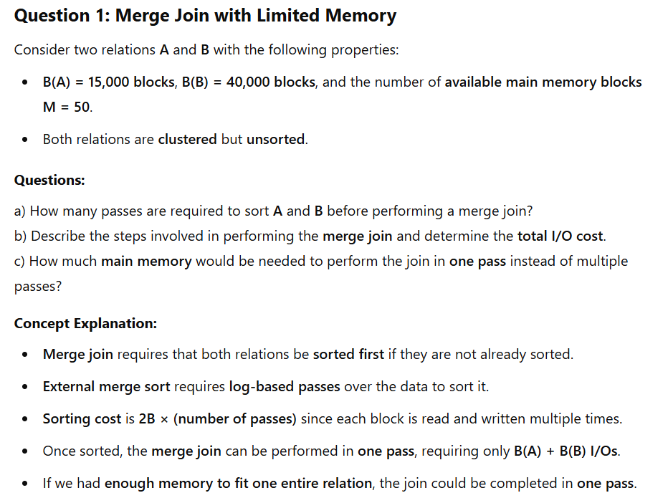
- 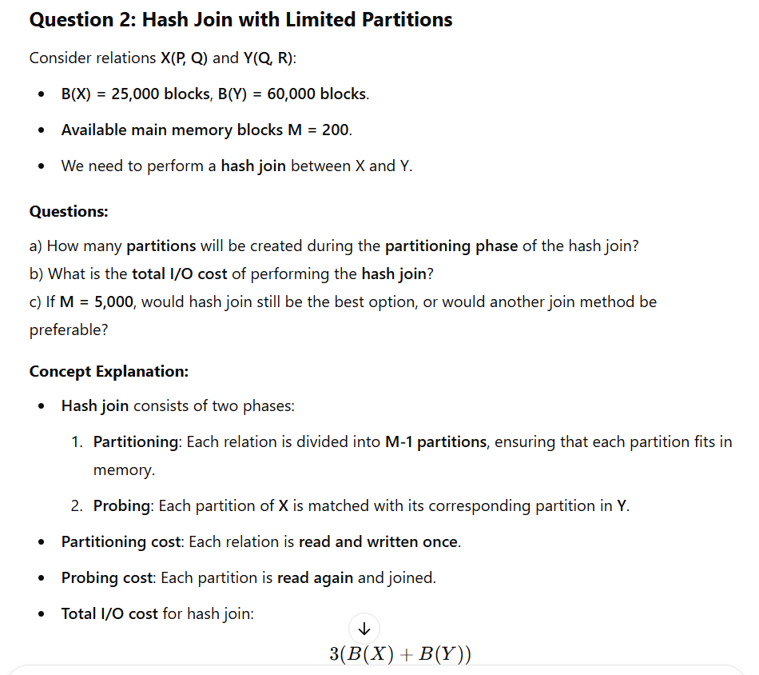If M is large enough to fit one relation entirely in memory, a one-pass join is possible.

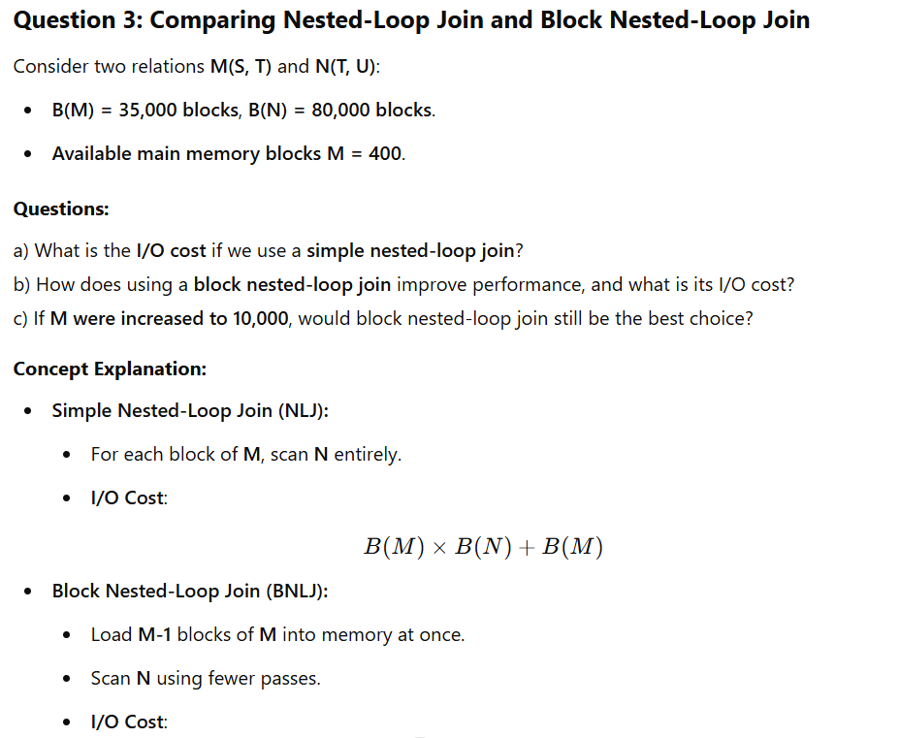
Here are three similar questions focusing on external sorting, I/O optimization, and efficient sorting techniques:

Question 3a: Sorting a Relation with a Limited Memory Budget
We need to sort the tuples of a relation S on a given key. The following details are provided:
- Relation S contains 200,000 tuples, i.e., T(S) = 200,000.
- The size of a block on disk is 8,000 bytes.
- The size of each tuple is 500 bytes.
- Relation S is clustered.
- The sort key size is 40 bytes, and a record pointer is 8 bytes.
Questions:
a) What is the minimum number of main memory blocks required to sort the relation using a two-pass sorting algorithm?
b) What is the total disk I/O cost for sorting S using the two-pass algorithm, including writing the final sorted relation back to disk?
c) If we modify the sorting algorithm to sort only the <key, recordPointer> pairs instead of the full tuples (using a technique similar to an index sort), how does this affect the I/O cost?
Concept Explanation:
- The two-pass sorting algorithm requires enough memory to handle B(S) / M sorted runs in one merge pass.
- Sorting only key-pointer pairs reduces I/O costs since fewer data blocks are read/written.
- The total I/O cost consists of reading, writing, and merging the sorted runs.

Question 3b: External Merge Sort with Large Relation
We need to sort relation T using external merge sort. Given:
- Relation T has 500,000 tuples, i.e., T(T) = 500,000.
- Block size is 4,096 bytes.
- Each tuple is 512 bytes.
- T is not clustered, meaning tuples may not be packed efficiently in blocks.
- The available main memory has 500 blocks.
Questions:
a) How many passes are required for sorting T using external merge sort?
b) What is the total I/O cost, including the merge phase?
c) If we store the sorted relation as an index instead of full tuples, how much storage is saved, and what is the new I/O cost?
Concept Explanation:
- The number of passes in external merge sort depends on the initial sorted runs and how many runs we can merge at once.
- The total I/O cost is computed by summing all read/write operations in each phase.
- Using index-based sorting (sorting keys instead of tuples) reduces storage and I/O costs.

Question 3c: Optimizing External Sorting with Indexed Sorting
We consider a scenario where we optimize sorting by only sorting keys and pointers.
- Relation U has 1,000,000 tuples, i.e., T(U) = 1,000,000.
- Block size = 8,192 bytes.
- Each tuple is 1,024 bytes.
- Sort key = 64 bytes, and each record pointer is 8 bytes.
- The relation is clustered.
- Available main memory has 1,000 blocks.
Questions:
a) How many sorted runs are produced in the initial pass of external sorting?
b) If we only sort <key, recordPointer> pairs, what is the new disk I/O cost?
c) How does sorting only index entries instead of full tuples improve performance in DBMS query processing?
Concept Explanation:
- Sorting only key-pointer pairs significantly reduces the amount of data written to disk.
- The merge process then retrieves tuples from disk only when needed, reducing random I/O operations.
- This technique is often used in B+ tree index sorting for efficient query lookups.

